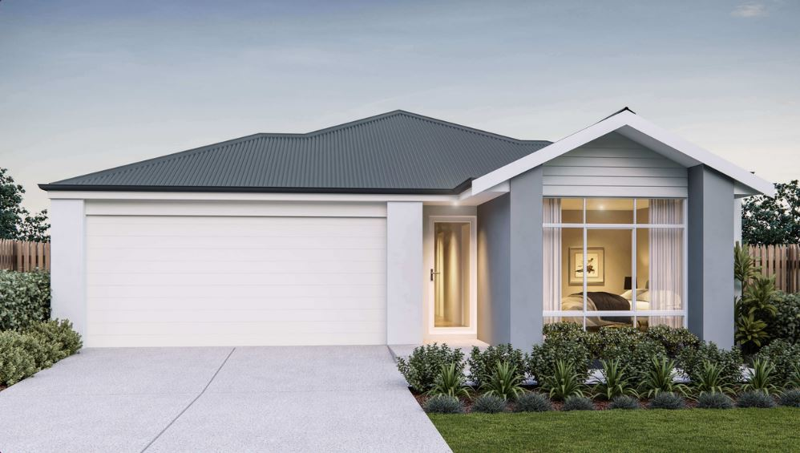  
  
  
  
  
  
  
  
  
  
  
  
  
  
  
  
  


**eastofthebeach.com.au | (08) 9754 8000**

**Celebration Homes – Ryan de Rozario**

| Land: 300m2

* Master bedroom with his and her robes
* Family area leading onto a spacious   
  alfresco
* Gallery kitchen with 900mm appliances
* Fencing & front/ rear landscaping included

Located facing the future ‘East of the Beach central park’ on a family friendly street - just 5 minutes from Shorehaven beach, this cleverly designed three-bedroom home is perfect for families who like their own space. Parents can enjoy their own sanctuary at the front of the home, with the kid’s bedrooms tucked away at the rear. The open plan living area is located at the centre of the home, which takes the saying ‘heart of the home’ to a whole new level.

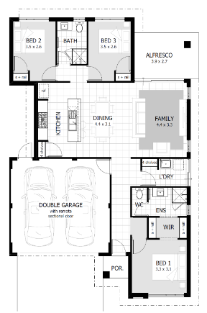

* 154sqm of total area
* Fixed price contract (No provisional sums!)
* High spec including brand name fixtures and fittings throughout
* Siteworks, soakwells & driveway crossover

**3**

**2**

**FEATURES**

***The Leo*** by Celebration Homes

***Lot 283 Sandpatch Parkway, East of the Beach***

**$350,100**

**2**